1. Problem Statement
Implement forward ray tracing where rays start at multiple point lights, hit several spheres (diffuse / reflective / transparent), bounce or refract, and reach the eye through a connection ray. This reverses the lecture's Eye → Object → Light direction to Light → Object → Eye.
2. Algorithm Choice
Three options: (A) random emission over 4π — wastes almost all rays; (B) photon mapping — needs a spatial map, heavy for this scope; (C) targeted emission (solid angle toward the spheres) + direct eye-connection + recursive reflection/refraction. Chosen: C — matches the lecture's closed-form intersection and Snell's law directly, needs no photon map, and scales to many spheres via a BVH if needed.
3. Scene## 4. Core Math
Ray: P(t) = O + tD, ‖D‖=1, t>0. Sphere k: center Cₖ, radius Rₖ.
At² + Bt + C = 0, with A=1, B = 2(O−Cₖ)·D, C = ‖O−Cₖ‖²−Rₖ²
Δ = B²−4C → Δ<0: miss; else t* = min{t₀,t₁ | t>ε}
P = O + t*D, N = (P−Cₖ)/Rₖ (see intersection-geometry figure above)
Reflection: R = D − 2(D·N)N
Refraction (η = η₁/η₂, cosθ₁ = −D·N): k = 1 − η²(1−(D·N)²); if k<0 → total internal reflection, else T = ηD + [η(D·N) − √k]N
Eye connection: V = (E−P)/‖E−P‖, test segment P→E against other spheres; blocked ⇒ discard.
Local shading: I_local = Iₐkₐ + Σᵢ Iₚᵢ[k_d·max(0,Lᵢ·N) + k_s·max(0,Rᵢ·V)^m]
Recursive total: I(P) = I_local + k_s·I(R) + k_t·I(T)
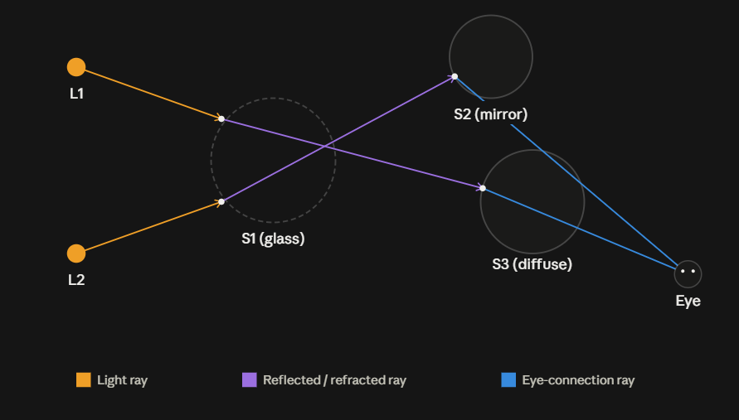
5. Pseudo-Algorithm
- Init spheres (Cₖ,Rₖ,k_d,k_s,k_t,ηₖ), lights L₁…Lₙ, eye E.
- For each light, sample directions only within the solid angle covering the spheres; set O=light, depth=0.
- Test ray against all spheres → compute A,B,C,Δ per sphere.
- Reject Δ<0; else take smallest t>ε over all spheres (nearest hit); if none, stop this ray.
- Compute P, N (flip N if ray is inside a transparent sphere).
- Build eye-connection ray P→E; test occlusion against other spheres; if blocked, don't project.
- If visible, project P to its pixel and add I_local.
- If k_s>0 and depth<MAX, spawn reflected ray R from P+εR, recurse.
- If k_t>0 and depth<MAX, compute refraction; k<0 → reflect only, else spawn transmitted ray T.
- Accumulate I(P)=I_local+k_s·I(R)+k_t·I(T); repeat for all rays/lights.
6. Findings
- Solid-angle-targeted emission avoids the huge ray waste of random forward tracing.
- Sphere intersection is closed-form → O(1) per sphere; O(M) per ray for M spheres (BVH speeds this up for large M).
- Nearest positive root = first physical surface hit.
- Multiple spheres need an occlusion test on the hit→eye segment (mutual blocking).
- k<0 in refraction ⇒ total internal reflection.
- Depth limit bounds the recursion; no photon map needed, keeping this feasible by hand.
Final choice: Option C — targeted forward tracing with direct eye-connection and recursive reflection/refraction — best fits multiple lights + multiple spheres while staying simpler than photon mapping and avoiding naive random-emission waste.

